Instructions OL Laser – very short version
------------------------------------------------------
After successful installation you should have a OL Laser icon on your Desk and under Start-Programs.
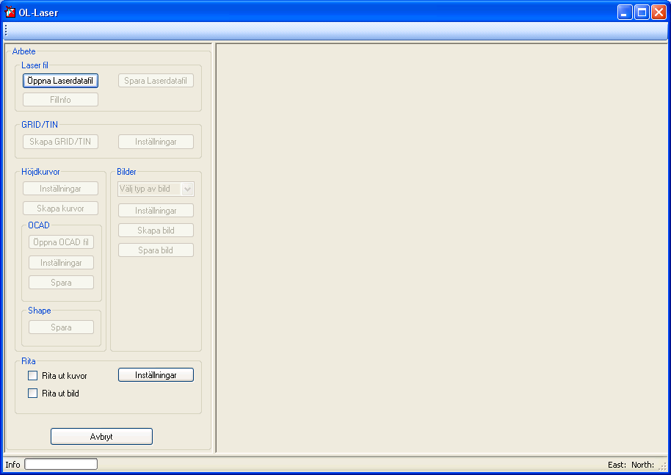
- You have to have a Laser file. You can get some demofiles from Lantmateriet homepage at http://www.lantmateriet.se/templates/LMV_Page.aspx?id=15721.
- Open the .las file – Click “Öppna Laserdatafil”. You can follow the progress down at the statusbar.
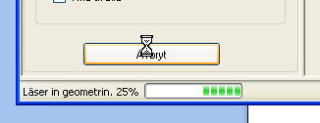
- Create the GRID – Click “Skapa GRID/TIN”. See the progress when finished.
- Choose which image you want to create.
Laserpunktklass – Pointclass image
Intensitet- intence image
Lutning – Slope image
Terrängskuggning – Shadow image
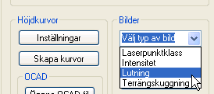
- Create the Image – Click “Skapa bild”. See the statusbar.
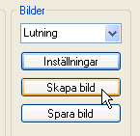
- See the Image in the program image window.
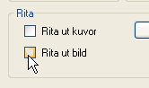
As you can see it is a lot of areas where the program did not calculate any slopes.
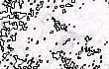
Go back to point 3, and before you create the GRID you can make some settings. Click “Inställningar”.
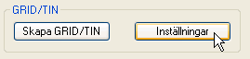
Choose “Alltid” (always) and then “OK” to close the
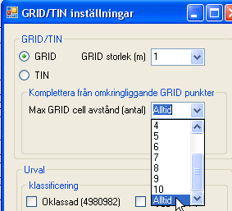

Create the GRID one more time.
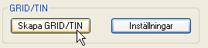
Continue with point 4,5,6.
The result maybe is better for your purposes now?
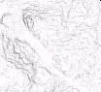

- If you are satisfied you can save the image – Click “Spara bild”
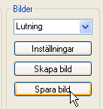

This was one example on a slope image. Now you have to experiment with the other options by yourself and as you have seen It is lot of settings to make and it can take some times to figure out the best images/curves for your purposes.

/jerker

